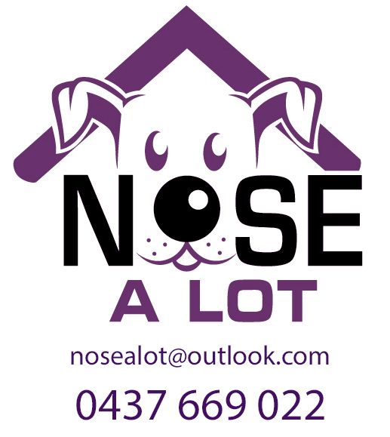
K9 Nose Work® Pre-Class
Questionaire
Geelong Show Grounds

Please take a moment to answer to following questions about you and your dog.
If you have more than one dog, please fill out a questionnaire for each dog, though you may skip the questions that have duplicate information about your background and interests.

Handler's Name:

Address:

Contact Phone No: E-mail Address:

Dog's Name: Breed

Dog's Age: Gender M MN F FS

Is your dog a: Companion Dog Performance/Sport Dog Other__________

Where did you get your dog? Shelter, Breeder, Friend, Pet Store, Foster/Rescue, Other

What age were they at that time?

Do you have any health considerations, issues, and/or concerns for you or your dog?
Yes No If you answered yes, please describe:

Does your dog have any food allergies?:

Have you ever competed with a dog? Yes No

With this dog? Yes No

Please check any previous activities or sports you have done with your dogs.
Agility
Tracking
Obedience
Rally
Other
None
If other, please explain:

Describe your dog's daily activity Level:

Please check off any fears (or nervousness) and phobias your dog may have, and please describe:
Strangers
Other dogs
Environment
Noise
Class Setting
Other
None
If other, please describe:

List in order of preference your dog's favourite items to play with (does not need to be a dog specific item):
1)

2)

List in order of preference your dog's favourite food/treats (either for training purposes or just to eat [be specific, chicken, hot dogs, sardine, sweet potato, wrapped fish]):
1)

2)

3)

4)

5)

How well does your dogs play with people other than you?

What are your expectations of this class?

What attracted you to this class?

